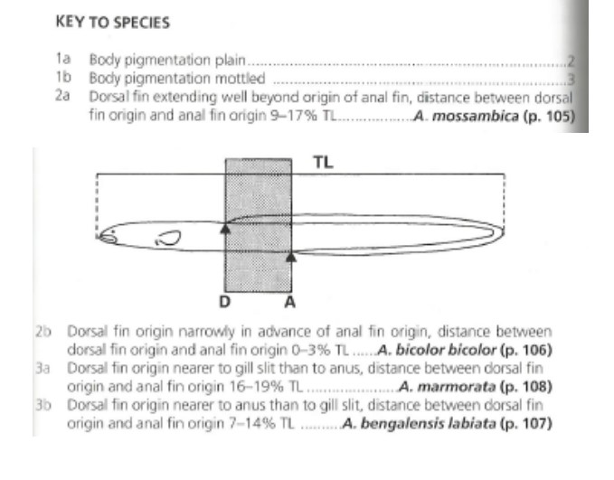

**This is the key I was referring to. So ie difference between the dorsal fin (DF) and Anal fin (AF)**

**This is an article I read of how someone calculated their differences but hawa they used Dorsal fin to anus:**

The fin difference index (FDI), which is the distance between the verticals from beginning of the dorsal fin (Z) to the anus (ano-dorsal length) relative to the total length (LT) (Ege, 1939), was calculated as follows: FDI ¼ 100 Z LT-1.

For us we’ll use Dorsal fin to anal fin.